**Exercise: Sorting data**

[Adventure Works Inventory](https://d3c33hcgiwev3.cloudfront.net/thgZ9WJSSjSfGBO41sT9Vg_851b0cfdbb8c4605b0971707cd6fa4e1_Adventure-Works-Inventory.xlsx?Expires=1732579200&Signature=HHb1GsHo~MCRd5jDyEGMicT1PatZWxCOah1457uK6cCdm2zHAS8~IpVRfJy4BLHIMC2f7wbG~ymYwrUQPp6g6gqNp04DhKB2UB2Utxq5B5mDUbPEzbuSsP7I6HwjoikOGLywqew283~d9RSn0gvFK2nAamU-46HqBgJTpC7ivog_&Key-Pair-Id=APKAJLTNE6QMUY6HBC5A" \t "_blank)

[XLSX File](https://d3c33hcgiwev3.cloudfront.net/thgZ9WJSSjSfGBO41sT9Vg_851b0cfdbb8c4605b0971707cd6fa4e1_Adventure-Works-Inventory.xlsx?Expires=1732579200&Signature=HHb1GsHo~MCRd5jDyEGMicT1PatZWxCOah1457uK6cCdm2zHAS8~IpVRfJy4BLHIMC2f7wbG~ymYwrUQPp6g6gqNp04DhKB2UB2Utxq5B5mDUbPEzbuSsP7I6HwjoikOGLywqew283~d9RSn0gvFK2nAamU-46HqBgJTpC7ivog_&Key-Pair-Id=APKAJLTNE6QMUY6HBC5A" \t "_blank)

**Introduction**

By now you should be familiar with the sorting feature in Microsoft Excel. In this exercise, you’ll reorganize the data in a worksheet so that rows are grouped in a particular order. You’ll do this by using both standard and multi-level sorts. By completing this exercise, you’ll be able to use these skills to sort numbers and text on large worksheets in a focused way.

**Case study**

Jamie at Adventure Works wants to improve the company’s product inventory file. This includes making the data easier to read and locate. You are part of the team creating the inventory for submission to a management review. You are familiarizing yourself with the content in the inventory file and decide to use the **Sort** feature to organize the data to suit your requirements.

**Step 1: Download and customize the file**

1. Download and open the Microsoft Excel workbook *Adventure Works Inventory.xlsx*. The file should contain one worksheet named **Products** that consists of 151 rows and 9 columns.

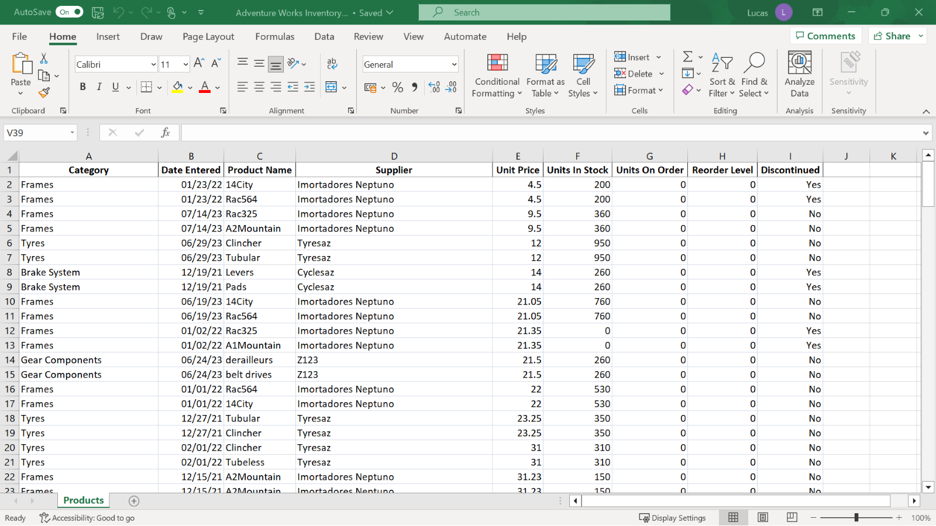

1. You are using the **Sort** feature to rearrange the data. So, add a visual marker in the data to determine the effects of the different sorts. Select cells **A32** to **I32** and apply a yellow background. On the **Home** tab, select the **Font** group, then select the **background color.**

**Step 2: Performing alpha-numeric sorts**

1. View the data organized by **Product Name** in ascending order.

**Tip:** Don’t forget to have the cursor in the correct column before selecting the **Sort** choice. Also, don’t forget that **Undo** will reverse a sort if you’ve made an error. Monitor the position of the colored row to ensure that the sort is working as you expect.

1. Sort the data by **Product Name** in descending order.
2. Sort the data by **Date Entered** so that the oldest entry is at the top.

**Tip:** Excel stores dates as numbers, so this will be a numeric sort.

1. Sort the data by **Supplier** using the shortcut **Sort Ascending** button.
2. Apply a sort that sorts the data by **Supplier** in ascending order and then by **Units in Stock** in descending order.

**Tip:** Remember the **Sort** choice in the data ribbon.

1. Reverse this sort using the **Undo** feature.

**Conclusion**

You have helped Adventure Works to re-organize its product inventory file using the **Sort** feature in Microsoft Excel. The **Sort** feature in Microsoft Excel can help you to reorganize data in many ways. By using these sorting techniques, you can work more efficiently and quickly with large worksheets.